**WEEK 4**

**Module 7 - Spring REST using Spring Boot 3**

**1.SPRING REST HANDS ON**

**Hands on 1 - Create a Spring Web Project using Maven**

**CODE:**

**pom.xml**

<project xmlns="http://maven.apache.org/POM/4.0.0"

xmlns:xsi="http://www.w3.org/2001/XMLSchema-instance"

xsi:schemaLocation="http://maven.apache.org/POM/4.0.0

https://maven.apache.org/xsd/maven-4.0.0.xsd">

<modelVersion>4.0.0</modelVersion>

<groupId>com.cognizant</groupId>

<artifactId>spring-learn</artifactId>

<version>0.0.1-SNAPSHOT</version>

<name>spring-learn</name>

<description>Spring Learn Demo</description>

<packaging>jar</packaging>

<parent>

<groupId>org.springframework.boot</groupId>

<artifactId>spring-boot-starter-parent</artifactId>

<version>3.2.5</version>

<relativePath/> <!-- lookup parent from repository -->

</parent>

<properties>

<java.version>17</java.version>

</properties>

<dependencies>

<dependency>

<groupId>org.springframework.boot</groupId>

<artifactId>spring-boot-starter-web</artifactId>

</dependency>

<dependency>

<groupId>org.springframework.boot</groupId>

<artifactId>spring-boot-devtools</artifactId>

<scope>runtime</scope>

<optional>true</optional>

</dependency>

<dependency>

<groupId>org.springframework.boot</groupId>

<artifactId>spring-boot-starter-test</artifactId>

<scope>test</scope>

</dependency>

</dependencies>

<build>

<plugins>

<plugin>

<groupId>org.springframework.boot</groupId>

<artifactId>spring-boot-maven-plugin</artifactId>

</plugin>

</plugins>

</build>

</project>

**src/main/java/com/cognizant**

**SpringLearnApplication.java**

package com.cognizant;

import org.springframework.boot.SpringApplication;

import org.springframework.boot.autoconfigure.SpringBootApplication;

import org.slf4j.Logger;

import org.slf4j.LoggerFactory;

@SpringBootApplication

public class SpringLearnApplication {

private static final Logger logger = LoggerFactory.getLogger(SpringLearnApplication.class);

public static void main(String[] args) {

SpringApplication.run(SpringLearnApplication.class, args);

logger.debug("Debug log from SpringLearnApplication");

logger.info("Info log from SpringLearnApplication");

}

}

**src/main/resources**

**application.properties**

logging.level.root=INFO

logging.level.com.cognizant=DEBUG

server.port=8085

**src/test/java/com/cognizant**

**SpringLearnApplicationTests.java**

package com.cognizant;

import org.junit.jupiter.api.Test;

import org.springframework.boot.test.context.SpringBootTest;

@SpringBootTest

class SpringLearnApplicationTests {

@Test

void contextLoads() {

    }

}

**OUTPUT:** 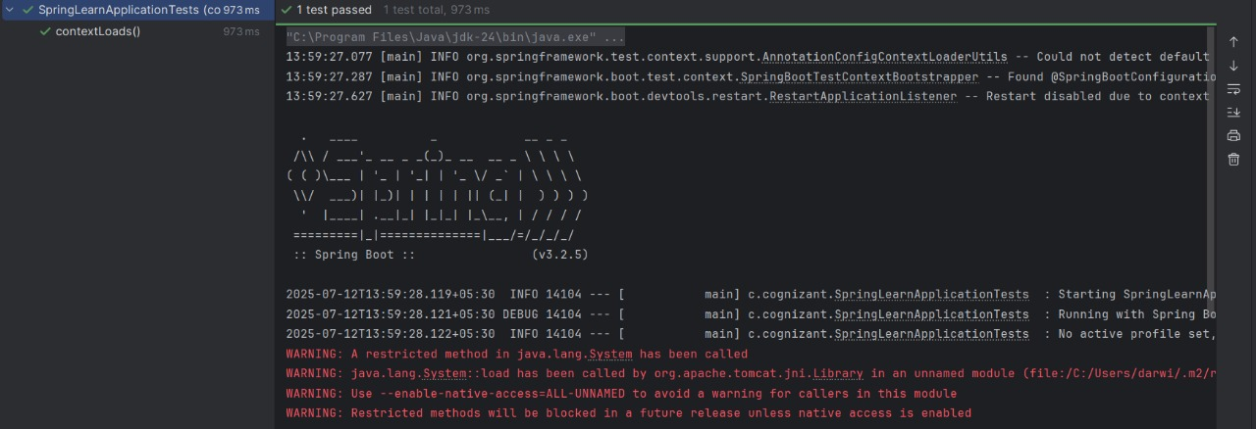

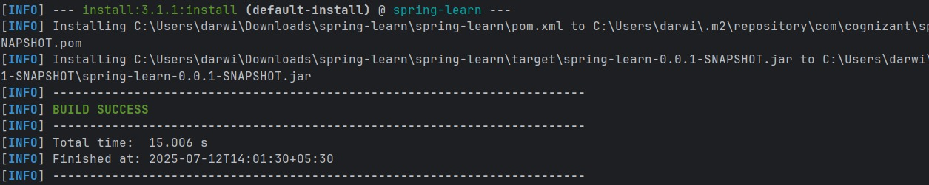

**Hands on 2 - Spring Core – Load SimpleDateFormat from Spring Configuration XML**

**CODE:**

**pom.xml**

<project xmlns="http://maven.apache.org/POM/4.0.0"

xmlns:xsi="http://www.w3.org/2001/XMLSchema-instance"

xsi:schemaLocation="http://maven.apache.org/POM/4.0.0 http://maven.apache.org/xsd/maven-4.0.0.xsd">

<modelVersion>4.0.0</modelVersion>

<groupId>com.cognizant</groupId>

<artifactId>spring-learn</artifactId>

<version>0.0.1-SNAPSHOT</version>

<dependencies>

<dependency>

<groupId>org.springframework</groupId>

<artifactId>spring-context</artifactId>

<version>6.1.6</version>

</dependency>

</dependencies>

<build>

<plugins>

<plugin>

<groupId>org.codehaus.mojo</groupId>

<artifactId>exec-maven-plugin</artifactId>

<version>3.1.0</version>

</plugin>

<plugin>

<groupId>org.codehaus.mojo</groupId>

<artifactId>exec-maven-plugin</artifactId>

<version>3.1.0</version>

<configuration>

<mainClass>com.cognizant.SpringLearnApplication</mainClass>

</configuration>

</plugin>

</plugins>

</build>

</project>

**src/main/resources**

**date-format.xml**

<?xml version="1.0" encoding="UTF-8"?>

<beans xmlns="http://www.springframework.org/schema/beans"

xmlns:xsi="http://www.w3.org/2001/XMLSchema-instance"

xsi:schemaLocation="http://www.springframework.org/schema/beans

https://www.springframework.org/schema/beans/spring-beans.xsd">

<bean id="dateFormat" class="java.text.SimpleDateFormat">

<constructor-arg value="dd/MM/yyyy" />

</bean>

</beans>

**src/main/java/com/cognizant**

**SpringLearnApplication.java**

public class SpringLearnApplication {

public static void main(String[] args) throws Exception {

displayDate();

}

public static void displayDate() throws Exception {

ApplicationContext context = new ClassPathXmlApplicationContext("date-format.xml");

SimpleDateFormat format = context.getBean("dateFormat", SimpleDateFormat.class);

Date date = format.parse("31/12/2018");

System.out.println(date);

    }

}

**OUTPUT:**

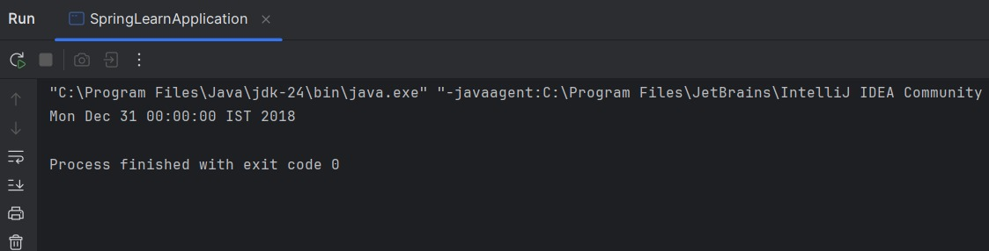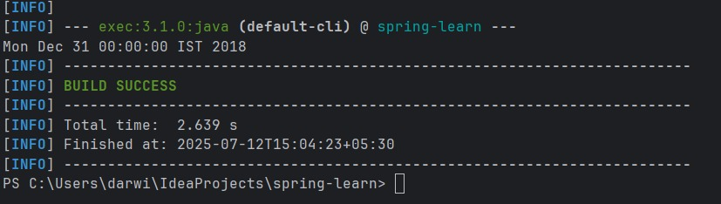

**Hands on 3 - Spring Core - Incorporate Logging**

**CODE:**

**pom.xml**

<project xmlns="http://maven.apache.org/POM/4.0.0"

xmlns:xsi="http://www.w3.org/2001/XMLSchema-instance"

xsi:schemaLocation="http://maven.apache.org/POM/4.0.0 http://maven.apache.org/xsd/maven-4.0.0.xsd">

<modelVersion>4.0.0</modelVersion>

<groupId>com.cognizant</groupId>

<artifactId>spring-learn</artifactId>

<version>0.0.1-SNAPSHOT</version>

<dependencies>

<dependency>

<groupId>org.springframework</groupId>

<artifactId>spring-context</artifactId>

<version>5.3.34</version>

</dependency>

<dependency>

<groupId>ch.qos.logback</groupId>

<artifactId>logback-classic</artifactId>

<version>1.2.12</version>

</dependency>

<dependency>

<groupId>org.slf4j</groupId>

<artifactId>slf4j-api</artifactId>

<version>1.7.36</version>

</dependency>

</dependencies>

<build>

<plugins>

<plugin>

<groupId>org.codehaus.mojo</groupId>

<artifactId>exec-maven-plugin</artifactId>

<version>3.1.0</version>

</plugin>

<plugin>

<groupId>org.codehaus.mojo</groupId>

<artifactId>exec-maven-plugin</artifactId>

<version>3.1.0</version>

<configuration>

<mainClass>com.cognizant.SpringLearnApplication</mainClass>

</configuration>

</plugin>

</plugins>

</build>

</project>

**src/main/resources**

**date-format.xml**

<?xml version="1.0" encoding="UTF-8"?>

<beans xmlns="http://www.springframework.org/schema/beans"

xmlns:xsi="http://www.w3.org/2001/XMLSchema-instance"

xsi:schemaLocation="http://www.springframework.org/schema/beans

https://www.springframework.org/schema/beans/spring-beans.xsd">

<bean id="dateFormat" class="java.text.SimpleDateFormat">

<constructor-arg value="dd/MM/yyyy"/>

</bean>

</beans>

**src/main/resources**

**application.properties**

logging.level.org.springframework=info

logging.level.com.cognizant=debug

logging.pattern.console=%d{yyMMdd}|%d{HH:mm:ss.SSS}|%-20.20thread|%5p|%-25.25logger{25}|%25M|%m%n

**src/main/java/com/cognizant**

**SpringLearnApplication.java**

package org.cognizant;

import java.text.SimpleDateFormat;

import java.util.Date;

import org.slf4j.Logger;

import org.slf4j.LoggerFactory;

import org.springframework.context.ApplicationContext;

import org.springframework.context.support.ClassPathXmlApplicationContext;

public class SpringLearnApplication {

private static final Logger LOGGER = LoggerFactory.getLogger(SpringLearnApplication.class);

public static void main(String[] args) throws Exception {

displayDate();

} public static void displayDate() throws Exception {

LOGGER.info("START");

ApplicationContext context = new ClassPathXmlApplicationContext("date-format.xml");

SimpleDateFormat format = context.getBean("dateFormat", SimpleDateFormat.class);

Date date = format.parse("31/12/2018");

LOGGER.debug(date.toString());

LOGGER.info("END");

}

}

**OUTPUT:**

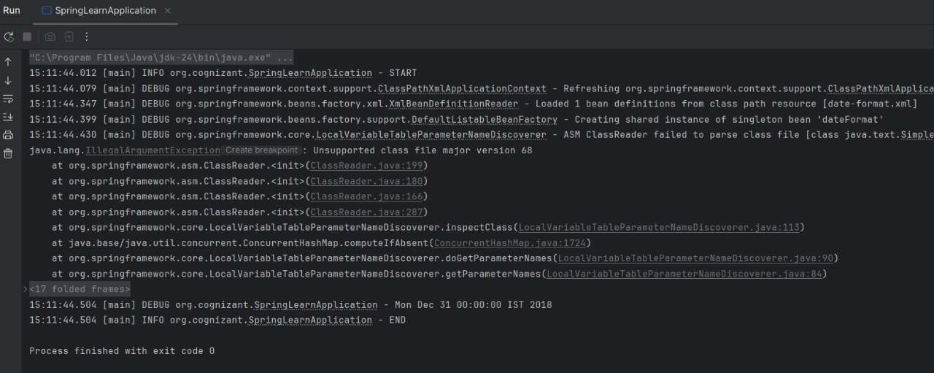

**Hands on 4 - Spring Core – Load Country from Spring Configuration XML**

**CODE:**

**pom.xml**

<project xmlns="http://maven.apache.org/POM/4.0.0"

xmlns:xsi="http://www.w3.org/2001/XMLSchema-instance"

xsi:schemaLocation="http://maven.apache.org/POM/4.0.0 http://maven.apache.org/xsd/maven-4.0.0.xsd">

<modelVersion>4.0.0</modelVersion>

<groupId>com.cognizant</groupId>

<artifactId>spring-learn</artifactId>

<version>0.0.1-SNAPSHOT</version>

<dependencies>

<dependency>

<groupId>org.springframework</groupId>

<artifactId>spring-context</artifactId>

<version>5.3.34</version>

</dependency>

<dependency>

<groupId>org.slf4j</groupId>

<artifactId>slf4j-api</artifactId>

<version>1.7.36</version>

</dependency>

<dependency>

<groupId>ch.qos.logback</groupId>

<artifactId>logback-classic</artifactId>

<version>1.2.12</version>

</dependency>

</dependencies>

<build>

<plugins>

<plugin>

<groupId>org.codehaus.mojo</groupId>

<artifactId>exec-maven-plugin</artifactId>

<version>3.1.0</version>

</plugin>

<plugin>

<groupId>org.codehaus.mojo</groupId>

<artifactId>exec-maven-plugin</artifactId>

<version>3.1.0</version>

<configuration>

<mainClass>com.cognizant.SpringLearnApplication</mainClass>

</configuration>

</plugin>

</plugins>

</build>

</project>

**src/main/java/com/cognizant**

**SpringLearnApplication.java**

package com.cognizant.springlearn;

import org.slf4j.Logger;

import org.slf4j.LoggerFactory;

import org.springframework.context.ApplicationContext;

import org.springframework.context.support.ClassPathXmlApplicationContext;

public class SpringLearnApplication {

private static final Logger LOGGER = LoggerFactory.getLogger(SpringLearnApplication.class);

public static void main(String[] args) {

displayCountry();

}

public static void displayCountry() {

LOGGER.info("START");

ApplicationContext context = new ClassPathXmlApplicationContext("country.xml");

Country country = context.getBean("country", Country.class);

LOGGER.debug("Country : {}", country.toString());

LOGGER.info("END");

}

}

**src/main/java/com/cognizant**

**Country.java**

package com.cognizant.springlearn;

import org.slf4j.Logger;

import org.slf4j.LoggerFactory;

public class Country {

private static final Logger LOGGER = LoggerFactory.getLogger(Country.class);

private String code;

private String name;

public Country() {

LOGGER.debug("Inside Country Constructor.");

}

public String getCode() {

LOGGER.debug("Inside getCode");

return code;

}

public void setCode(String code) {

LOGGER.debug("Inside setCode");

this.code = code;

}

public String getName() {

LOGGER.debug("Inside getName");

return name;

}

public void setName(String name) {

LOGGER.debug("Inside setName");

this.name = name;

}

@Override

public String toString() {

return "Country [code=" + code + ", name=" + name + "]";

}

}

**src/main/resources**

**application.properties**

logging.level.org.springframework=info

logging.level.com.cognizant.springlearn=debug

logging.pattern.console=%d{yyMMdd}|%d{HH:mm:ss.SSS}|%-20.20thread|%5p|%-25.25logger{25}|%25M|%m%n

**src/main/resources**

**Country.xml**

<?xml version="1.0" encoding="UTF-8"?>

<beans xmlns="http://www.springframework.org/schema/beans"

xmlns:xsi="http://www.w3.org/2001/XMLSchema-instance"

xsi:schemaLocation="http://www.springframework.org/schema/beans

https://www.springframework.org/schema/beans/spring-beans.xsd">

<bean id="country" class="com.cognizant.springlearn.Country">

<property name="code" value="IN" />

<property name="name" value="India" />

</bean>

</beans>

**OUTPUT:**

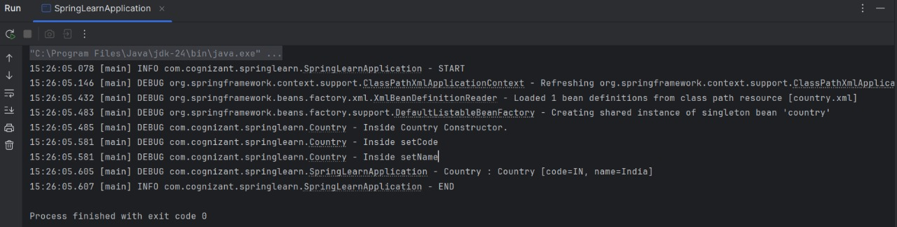

**bean tag**

Defines an object to be managed by Spring. Example:

<bean id="country" class="com.cognizant.springlearn.Country"/>

**id attribute**

Unique name for the bean used to retrieve it.

**class attribute**

Fully qualified class name of the bean to instantiate.

**property tag**

Used to inject values or references to fields.

**name and value attributes**

name: field name to set (e.g., code)

value: value to inject (e.g., "IN")

**ApplicationContext**

The central interface to Spring’s IoC container used to get beans.

**ClassPathXmlApplicationContext**

Loads configuration from the classpath (like country.xml).

**What happens during context.getBean()**

* Spring reads the bean definition from the XML file.
* It instantiates the bean using the constructor.
* It injects property values via setters.
* It returns the fully constructed and initialized object.

**Hands on 5 - Spring Core – Demonstration of Singleton Scope and Prototype Scope**

**CODE:**

**pom.xml**

<project xmlns="http://maven.apache.org/POM/4.0.0"

xmlns:xsi="http://www.w3.org/2001/XMLSchema-instance"

xsi:schemaLocation="http://maven.apache.org/POM/4.0.0 http://maven.apache.org/xsd/maven-4.0.0.xsd">

<modelVersion>4.0.0</modelVersion>

<groupId>com.cognizant</groupId>

<artifactId>spring-learn</artifactId>

<version>0.0.1-SNAPSHOT</version>

<dependencies>

<dependency>

<groupId>org.springframework</groupId>

<artifactId>spring-context</artifactId>

<version>5.3.34</version>

</dependency>

<dependency>

<groupId>org.slf4j</groupId>

<artifactId>slf4j-api</artifactId>

<version>1.7.36</version>

</dependency>

<dependency>

<groupId>ch.qos.logback</groupId>

<artifactId>logback-classic</artifactId>

<version>1.2.12</version>

</dependency>

</dependencies>

<build>

<plugins>

<plugin>

<groupId>org.codehaus.mojo</groupId>

<artifactId>exec-maven-plugin</artifactId>

<version>3.1.0</version>

</plugin>

<plugin>

<groupId>org.codehaus.mojo</groupId>

<artifactId>exec-maven-plugin</artifactId>

<version>3.1.0</version>

<configuration>

<mainClass>com.cognizant.SpringLearnApplication</mainClass>

</configuration>

</plugin>

</plugins>

</build>

</project>

**src/main/java/com/cognizant**

**SpringLearnApplication.java**

package com.cognizant.springlearn;

import org.slf4j.Logger;

import org.slf4j.LoggerFactory;

import org.springframework.context.ApplicationContext;

import org.springframework.context.support.ClassPathXmlApplicationContext;

public class SpringLearnApplication {

private static final Logger LOGGER = LoggerFactory.getLogger(SpringLearnApplication.class);

public static void main(String[] args) {

displayCountry();

}

public static void displayCountry() {

LOGGER.info("START");

ApplicationContext context = new ClassPathXmlApplicationContext("country.xml");

Country country = context.getBean("country", Country.class);

LOGGER.debug("Country : {}", country.toString());

Country anotherCountry = context.getBean("country", Country.class);

LOGGER.debug("Another Country : {}", anotherCountry.toString());

LOGGER.debug("country == anotherCountry: {}", country == anotherCountry);

LOGGER.info("END");

}

}

**src/main/java/com/cognizant**

**Country.java**

package com.cognizant.springlearn;

import org.slf4j.Logger;

import org.slf4j.LoggerFactory;

public class Country {

private static final Logger LOGGER = LoggerFactory.getLogger(Country.class);

private String code;

private String name;

public Country() {

LOGGER.debug("Inside Country Constructor.");

}

public String getCode() {

LOGGER.debug("Getting code");

return code;

}

public void setCode(String code) {

LOGGER.debug("Setting code");

this.code = code;

}

public String getName() {

LOGGER.debug("Getting name");

return name;

}

public void setName(String name) {

LOGGER.debug("Setting name");

this.name = name;

}

@Override

public String toString() {

return "Country [code=" + code + ", name=" + name + "]";

}

}

**src/main/resources**

**application.properties**

logging.level.org.springframework=info

logging.level.com.cognizant.springlearn=debug

logging.pattern.console=%d{yyMMdd}|%d{HH:mm:ss.SSS}|%-20.20thread|%5p|%-25.25logger{25}|%25M|%m%n

**src/main/resources**

**Country.xml**

<?xml version="1.0" encoding="UTF-8"?>

<beans xmlns="http://www.springframework.org/schema/beans"

xmlns:xsi="http://www.w3.org/2001/XMLSchema-instance"

xsi:schemaLocation="http://www.springframework.org/schema/beans

https://www.springframework.org/schema/beans/spring-beans.xsd">

<bean id="country" class="com.cognizant.springlearn.Country">

<property name="code" value="IN"/>

<property name="name" value="India"/>

</bean>

</beans>

**OUTPUT:**

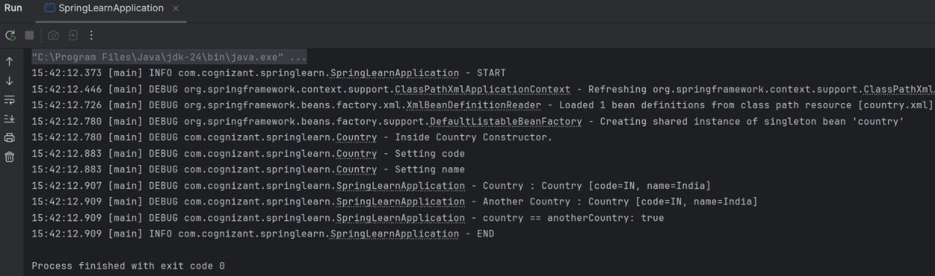

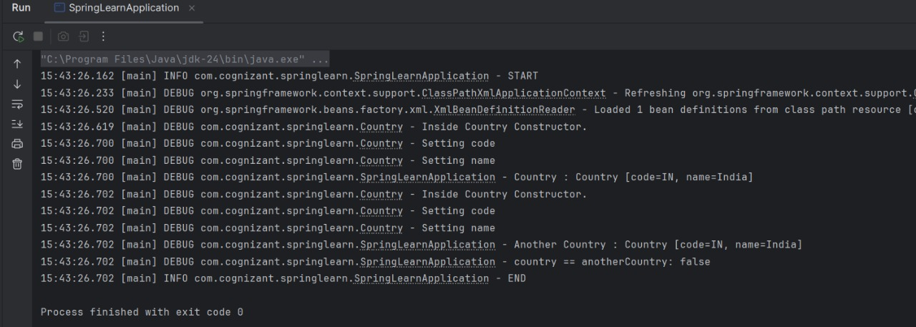

**Hands on 6 - Spring Core – Load list of countries from Spring Configuration XML**

**CODE:**

**pom.xml**

<project xmlns="http://maven.apache.org/POM/4.0.0"

xmlns:xsi="http://www.w3.org/2001/XMLSchema-instance"

xsi:schemaLocation="http://maven.apache.org/POM/4.0.0 http://maven.apache.org/xsd/maven-4.0.0.xsd">

<modelVersion>4.0.0</modelVersion>

<groupId>com.cognizant</groupId>

<artifactId>spring-learn</artifactId>

<version>0.0.1-SNAPSHOT</version>

<dependencies>

<dependency>

<groupId>org.springframework</groupId>

<artifactId>spring-context</artifactId>

<version>5.3.34</version>

</dependency>

<dependency>

<groupId>org.slf4j</groupId>

<artifactId>slf4j-api</artifactId>

<version>1.7.36</version>

</dependency>

<dependency>

<groupId>ch.qos.logback</groupId>

<artifactId>logback-classic</artifactId>

<version>1.2.12</version>

</dependency>

</dependencies>

<build>

<plugins>

<plugin>

<groupId>org.codehaus.mojo</groupId>

<artifactId>exec-maven-plugin</artifactId>

<version>3.1.0</version>

</plugin>

<plugin>

<groupId>org.codehaus.mojo</groupId>

<artifactId>exec-maven-plugin</artifactId>

<version>3.1.0</version>

<configuration>

<mainClass>com.cognizant.SpringLearnApplication</mainClass>

</configuration>

</plugin>

</plugins>

</build>

</project>

**src/main/java/com/cognizant**

**SpringLearnApplication.java**

package com.cognizant.springlearn;

import java.util.List;

import org.slf4j.Logger;

import org.slf4j.LoggerFactory;

import org.springframework.context.ApplicationContext;

import org.springframework.context.support.ClassPathXmlApplicationContext;

public class SpringLearnApplication {

private static final Logger LOGGER = LoggerFactory.getLogger(SpringLearnApplication.class);

public static void main(String[] args) {

displayCountries();

}

public static void displayCountries() {

LOGGER.info("START");

ApplicationContext context = new ClassPathXmlApplicationContext("country.xml");

List<Country> countryList = context.getBean("countryList", List.class);

LOGGER.debug("Country List: {}", countryList);

LOGGER.info("END");

}

}

**src/main/java/com/cognizant**

**Country.java**

package com.cognizant.springlearn;

import org.slf4j.Logger;

import org.slf4j.LoggerFactory;

public class Country {

private static final Logger LOGGER = LoggerFactory.getLogger(Country.class);

private String code;

private String name;

public Country() {

LOGGER.debug("Inside Country Constructor.");

}

public String getCode() {

LOGGER.debug("Inside getCode()");

return code;

}

public void setCode(String code) {

LOGGER.debug("Inside setCode()");

this.code = code;

}

public String getName() {

LOGGER.debug("Inside getName()");

return name;

}

public void setName(String name) {

LOGGER.debug("Inside setName()");

this.name = name;

}

@Override

public String toString() {

return "Country [code=" + code + ", name=" + name + "]";

}

}

**src/main/resources**

**application.properties**

logging.level.org.springframework=info

logging.level.com.cognizant.springlearn=debug

logging.pattern.console=%d{yyMMdd}|%d{HH:mm:ss.SSS}|%-20.20thread|%5p|%-25.25logger{25}|%25M|%m%n

**src/main/resources**

**Country.xml**

<?xml version="1.0" encoding="UTF-8"?>

<beans xmlns="http://www.springframework.org/schema/beans"

xmlns:xsi=<http://www.w3.org/2001/XMLSchema-instance>

xsi:schemaLocation="http://www.springframework.org/schema/beans

https://www.springframework.org/schema/beans/spring-beans.xsd">

<bean id="in" class="com.cognizant.springlearn.Country">

<property name="code" value="IN" />

<property name="name" value="India" />

</bean>

<bean id="us" class="com.cognizant.springlearn.Country">

<property name="code" value="US" />

<property name="name" value="United States" />

</bean>

<bean id="de" class="com.cognizant.springlearn.Country">

<property name="code" value="DE" />

<property name="name" value="Germany" />

</bean>

<bean id="jp" class="com.cognizant.springlearn.Country">

<property name="code" value="JP" />

<property name="name" value="Japan" />

</bean>

<bean id="countryList" class="java.util.ArrayList">

<constructor-arg>

<list>

<ref bean="in"/>

<ref bean="us"/>

<ref bean="de"/>

<ref bean="jp"/>

</list>

</constructor-arg>

</bean>

</beans>

**OUTPUT:**